Response to request for an update on the outstanding repair issues from Lancashire County Council.

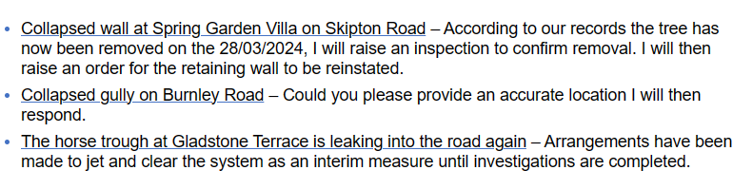
Furter response re blocked gulley on Burnley Road:
