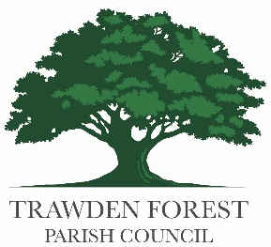

**Public Spaces Protection Order Consultation**

Pendle Borough Council are proposing to re-adopt the Public Spaces Protection Orders (PSPO) that cover all playgrounds, sports grounds and recreation grounds in Pendle.

**We are consulting on the rules that apply to Trawden Recreation Ground.**

In all other grounds in Pendle, except Trawden and one other, there are one or more of the following rules, relating to dogs:

* No dogs are permitted;

* No more than two dogs per walker and all dogs on leads of no more than two metres in length;

* No dogs at any time other than in the designated dog walking area.

We have been asked by Pendle Borough Council to decide what rules should apply to dogs on Trawden Recreation Ground. Would you like to see any of the following rules applied?

**No more than two dogs per walker and all dogs on leads of no more than two metres in length**

Yes No

**No dogs at any time other than in a designated area (subject to further consideration)**

Yes No

How often do you use the site? _______________________________________________________

For what purposes do you visit? _______________________________________________________

Where do you come from? Please give your postcode______________________________________

Any other comments?________________________________________________________________

__________________________________________________________________________________

__________________________________________________________________________________

This consultation is open from 17th October to 31st October 2024 and your responses can be completed online and emailed to a.waddington@trawdenparishcouncil.org.uk or left in the library or Old Rock Cafe.